**Experiment 3**

Aim: To show the implementation of Javascript/Jquery in the html website.

Theory:

**JavaScript** (**JS**) is a lightweight, interpreted, or just-in-time compiled programming language. While it is most well-known as the scripting language for Web pages, many-non browsing environments also use it, such as Node.js, Apache CouchDB and Adobe Acrobat. JavaScript is a prototype-based, multi-paradigm, single-threaded, dynamic language, supporting object-oriented, imperative, and declarative (e.g. functional programming) styles.

JavaScript's dynamic capabilities include runtime object construction, variable parameter lists, function variables, dynamic script creation (via eval), object introspection, and source-code recovery (JavaScript functions store their source text and can be retrieved through tostring()).

JavaScript is a scripting language that enables you to create dynamically updating content, control multimedia, animate images, and pretty much everything else.

Features of javascript used:

* Image slider-

An **Image Slide**r that comprises several images displayed on a web application is called “**Slide Show**” and “**Carousels**”. It permits you to show multiple images, videos, or graphics on a web application. Also, adding an Image Slider to a website can fascinate the users and capture their attention.

An image slider can be used in different sections of a website or mobile application. One example is to use it in the banner section of a website to create a banner slider. As multiple slides can be added to the banner section, it helps users to learn all the important things they need to know about the website immediately when they visit the page.

* Use of alert()

The **alert()** method in JavaScript is used to display a virtual alert box. It is mostly used to give a warning message to the users. It displays an alert dialog box that consists of some specified message (which is optional) and an OK button. When the dialog box pops up, we have to click "OK" to proceed. The alert dialog box takes the focus and forces the user to read the specified message So, we should avoid overusing this method because it stops the user from accessing the other parts of the webpage until the box is closed.

jQuery is a lightweight, "write less, do more", JavaScript library.

The purpose of jQuery is to make it much easier to use JavaScript on your website.

jQuery takes a lot of common tasks that require many lines of JavaScript code to accomplish, and wraps them into methods that you can call with a single line of code.

jQuery also simplifies a lot of the complicated things from JavaScript, like AJAX calls and DOM manipulation.

Jquery used :

* Tooltip : Tooltips are used with the element to display a title in the title box next to the element, when you hover the element with your mouse. Tooltips can be attached to any element. If you want to display tooltip, just add title attribute to input elements and the title attribute value will be used as tooltip.
* hover() : The hover() method specifies two functions to run when the mouse pointer hovers over the selected elements.
* hide() : The jQuery hide() method is used to hide the selected elements.

$(selector).hide();   $(selector).hide(speed, callback);   $(selector).hide(speed, easing, callback);

Java script code : (sliding) :

let flag=0;

function controller(x){

 flag = flag + x ;

 /* //left  flag = 2 + (-1) = 1  //right  flag = 2 + 1 = 3  */

slideshow(flag);

}

slideshow(flag);

function slideshow(num){

    let slidess = document.getElementsByClassName('slides');

    if(num == slidess.length){

          flag=0;

          num=0;

    }

    if(num<0){

        flag=slidess.length-1;

        num=slidess.length-1;

    }

    for(let y of slidess){

        y.style.display = "none";

    }

    slidess[num].style.display = "block";

}

Html Code :

<div class="slidecont">

    <div class="slides">

        <img src="C:\Users\Pratik\OneDrive\Desktop\wt project\slide\download (3).jpeg" alt="" height="500" width="200">

        <div class="caption">Bata Shoes</div>

    </div>

    <div class="slides">

        <img src="C:\Users\Pratik\OneDrive\Desktop\wt project\slide\download.jpeg" alt="" height="600">

        <div class="caption">Bata Ladies Chappal</div>

    </div>

    <div class="slides">

        <img src="C:\Users\Pratik\OneDrive\Desktop\wt project\slide\images.jpeg" alt="" height="600">

        <div class="caption">caption text 3</div>

    </div>

    <div class="slides">

        <img src="C:\Users\Pratik\OneDrive\Desktop\wt project\slide\spots5.jpg" alt="" height="550">

        <div class="caption">Bata Office Chappal</div>

    </div>

    <span class="arrow prev" onclick="controller(-1)">&#10094;</span>

    <span class="arrow next" onclick="controller(1)">&#10095;</span>

    <script src="exp1.js"> </script>

</div>

Jquery Code :  (hide and toolkit):

<div class="addbox">

  <j>  <marquee id="adt" title="you can hide this also" >Click On the adds to Hide it.</marquee>

        </j><br>

        <j><img src="C:\Users\Pratik\OneDrive\Desktop\wt project\adds\add1.jpeg" alt="add1"></j>

        <j><img src="C:\Users\Pratik\OneDrive\Desktop\wt project\adds\add2.jpeg" alt="add2"></j>

        <j><img src="C:\Users\Pratik\OneDrive\Desktop\wt project\adds\add3.jpeg" alt="add3"></j>

        <j><img src="C:\Users\Pratik\OneDrive\Desktop\wt project\adds\add4.jpeg" alt="add4"></j>

    </div>

    <script>

        $(document).ready(function () {

            $('j').click();

            $('j').click(function () {

                //console.log('you clicked on j ')

                alert('Are you sure you want to hide this add ?')

                $(this).hide();

                jQuery(".adt").toolTip()

            });

        });

        $('j').hover(function(){

            console.log('you hovered on',this);

            ('you can also hide this text')

        });

    </script>

CSS Code:

.slidecont{

    position: relative;

    width: 80%;

    padding: 10px;

    margin-left: 20px;

    margin-right: 20px;

}

.slides img{

    width: 90%;

    padding: 20px;

}

.arrow{

    cursor: pointer;

    position: absolute;

    top: 45%;

    color: black;

    background-color:rgba(255, 255, 255, 0.712);

    padding: 8px 18px ;

    border-radius: 50%;

    font-size: 25px;

    font-weight: bold;

}

.next{

    right: 10px;

}

.prev{

    left: 10px;

}

.caption{

    color: white;

    font-size: 30px;

    font-weight: bold;

    position: absolute;

    bottom: 0px;

    width: 100%;

    text-align: center;

    background-color: rgba(0, 0, 0, 0.5);

    padding:15px 0px;

}

.slides{

    display: none;

}

.slides img{

padding: 50px;

}

Java Script Output : ( sliding Images ) :



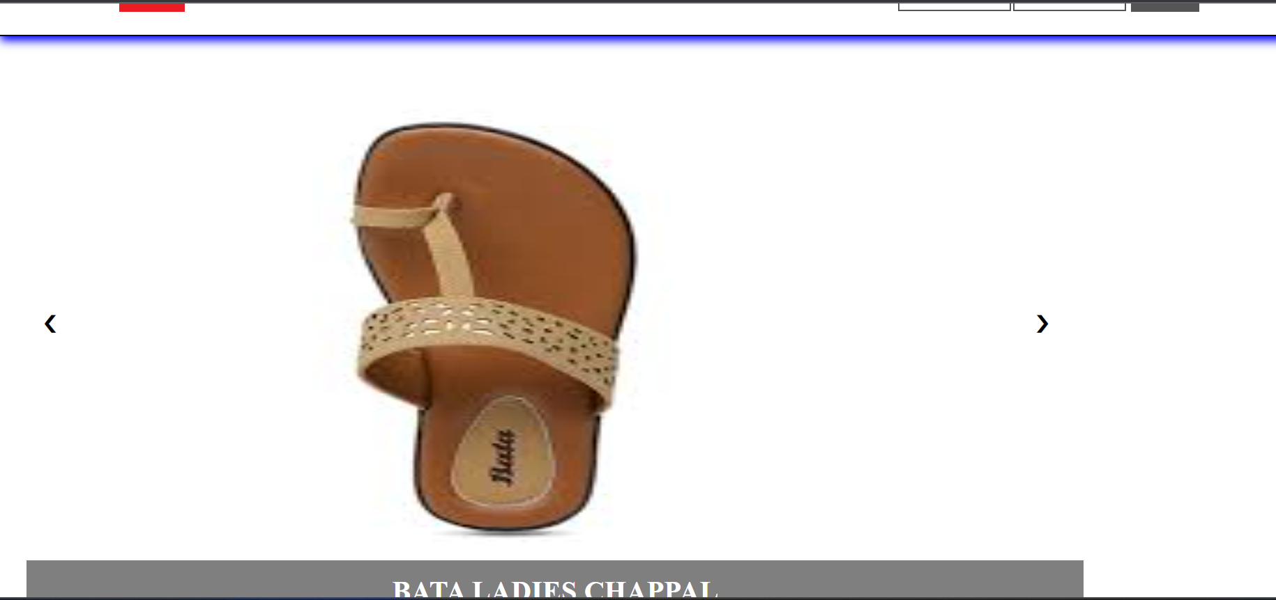







Conclusion :